UNITED STATES
SECURITIES AND EXCHANGE COMMISSION
Washington, D.C. 20549

FORM 8-K

CURRENT REPORT
Pursuant to Section 13 or 15(d)
of the Securities Exchange Act of 1934
Date of Report (Date of earliest event reported): August 6, 2026

BCP Investment Corporation
(Exact name of registrant as specified in its charter)

Delaware |  | 814-00735 |  | 20-5951150
(State or other jurisdiction  of incorporation) |  | (Commission  File Number) |  | (IRS Employer  Identification No.)

650 Madison Avenue, 3rd Floor  New York, New York |  | 10022
(Address of principal executive offices) |  | (Zip Code)
(Registrant’s telephone number, including area code): (212) 891-2880
Not Applicable
(Former name or former address, if changed since last report)

Check the appropriate box below if the Form 8-K filing is intended to simultaneously satisfy the filing obligation of the registrant under any of the following provisions (see General Instructions A.2. below):

☐ | Written communications pursuant to Rule 425 under the Securities Act (17 CFR 230.425)

☐ | Soliciting material pursuant to Rule 14a-12 under the Exchange Act (17 CFR 240.14a-12)

☐ | Pre-commencement communications pursuant to Rule 14d-2(b) under the Exchange Act (17 CFR 240.14d-2(b))

☐ | Pre-commencement communications pursuant to Rule 13e-4(c) under the Exchange Act (17 CFR 240.13e-4(c))
Securities registered pursuant to Section 12(b) of the Exchange Act:

Title of each class |  | Trading  Symbol(s) |  | Name of each exchange  on which registered
Common Stock, par value $0.01 per share |  | BCIC |  | The NASDAQ Global Select Market
Indicate by check mark whether the registrant is an emerging growth company as defined in Rule 405 of the Securities Act of 1933 (§ 230.405 of this chapter) or Rule 12b-2 of the Securities Exchange Act of 1934 (§ 240.12b-2 of this chapter).
Emerging growth company ☐
If an emerging growth company, indicate by check mark if the registrant has elected not to use the extended transition period for complying with any new or revised financial accounting standards provided pursuant to Section 13(a) of the Exchange Act. ☐

Item 2.02 | Results of Operations and Financial Condition.
On August 6, 2026, BCP Investment Corporation (the “Company”) issued a press release announcing its financial results for the fiscal quarter ended June 30, 2026. A copy of the press release is being furnished as Exhibit 99.1 to this Current Report on Form 8-K and is incorporated herein by reference. Additionally, on August 7, 2026, the Company made available on its website, https://www.bcpinvestmentcorporation.com/home, a supplemental investor presentation with respect to the earnings release. A copy of the investor presentation is being furnished as Exhibit 99.2 to this Current Report on Form 8-K and is incorporated herein by reference.
The information disclosed under this Item 2.02, including Exhibits 99.1 and 99.2 hereto, is being furnished and shall not be deemed “filed” for purposes of Section 18 of the Securities Exchange Act of 1934, as amended (the “Exchange Act”), or otherwise subject to the liabilities of that section, and shall not be deemed incorporated by reference into any filing made under the Securities Act of 1933, as amended, or the Exchange Act, except as expressly set forth by specific reference in such filing.

Item 9.01. | Financial Statements and Exhibits.
(d) Exhibits:

Exhibit Number |  | Description
99.1 |  | Press Release, dated August 6, 2026
99.2 |  | Investor Presentation, dated August 7, 2026
104 |  | Cover Page Interactive Data File (embedded within the Inline XBRL Document)

SIGNATURES
Pursuant to the requirements of the Securities Exchange Act of 1934, the Registrant has duly caused this report to be signed on its behalf by the undersigned hereunto duly authorized.

BCP INVESTMENT CORPORATION
By: |  | /s/ Brandon Satoren
Name: |  | Brandon Satoren
Title: |  | Chief Financial Officer
Date: August 7, 2026
Exhibit 99.1

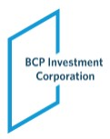
BCP Investment Corporation Announces Second Quarter 2026 Financial Results
Declares Monthly Base Distributions of $0.09 Per Share for October, November and December 2026
Amends KeyBank Credit Facility Subsequent to Quarter End, Increasing Committed Capacity to $150 Million, Reducing Reinvestment Period Spread by 30 Basis Points and Extending Maturity to 2031; Repays and Terminates JPMorgan Revolving Credit Facility
NEW YORK, August 6, 2026 – BCP Investment Corporation (NASDAQ: BCIC) (“BCIC” or “the Company”) announced today its financial results for the second quarter ended June 30, 2026.
Second Quarter 2026 Highlights

 |  |  | Total investment income for the second quarter of 2026 was $15.2 million as compared to $17.6 million for the first quarter of 2026.

 |  |  | Core investment income1, excluding the impact of purchase price accounting, for the second quarter of 2026 was $12.9 million, as compared to $14.8 million for the first quarter of 2026.

 |  |  | Net investment income (“NII”) for the second quarter of 2026 was $5.5 million ($0.45 per share), as compared to $6.9 million ($0.55 per share) in the first quarter of 2026.

 |  |  | Net asset value (“NAV”), as of June 30, 2026, was $179.5 million ($14.49 per share), as compared to NAV of $193.0 million ($15.60 per share) as of March 31, 2026. Approximately 34% of the quarter’s unrealized markdowns were attributable to investments classified as “Software” in our Consolidated Schedule of Investments, and approximately 47% when including software-exposed names.

 |  |  | Non-accrual investments decreased to 11 across 7 portfolio companies from 12 across 9 portfolio companies, representing 3.1% and 5.7% of the Company’s investment portfolio at fair value and amortized cost, respectively, as of June 30, 2026. This compares to 2.6% and 6.2% of the Company’s investment portfolio at fair value and amortized cost, respectively, as of March 31, 2026. As of June 30, 2026, for a subset of the non-accrual population, the Company continues to recognize interest income on a cash basis (i.e., only when cash payments are actually received).

1 | Core investment income represents reported total investment income as determined in accordance with U.S. generally accepted accounting principles, or U.S. GAAP, less the impact of purchase discount accretion in connection with the Garrison Capital Inc. (“GARS”), Harvest Capital Credit Corporation (“HCAP”), and Logan Ridge Finance Corporation (“LRFC”) mergers. BCIC believes presenting core investment income and the related per share amount is a useful and appropriate supplemental disclosure for analyzing its financial performance due to the unique circumstance giving rise to the purchase accounting adjustment. However, core investment income is a non-U.S. GAAP measure and should not be considered as a replacement for total investment income and other earnings measures presented in accordance with U.S. GAAP. Instead, core investment income should be reviewed only in connection with such U.S. GAAP measures in analyzing BCIC’s financial performance.

 |  |  | Deployment of approximately $20.9 million and repayments and sales of approximately $34.9 million, resulting in net repayments and sales of approximately $14.0 million.

 |  |  | Subsequent to quarter end, the Company amended its KeyBank Credit Facility, reducing the applicable borrowing spread from 2.80% to 2.50% during the reinvestment period and from 3.20% to 3.00% during the amortization period, extending the reinvestment period to August 2029 and the maturity date to August 2031, and increasing committed capacity under the facility from $75.0 million to $150.0 million. Borrowings under the amended facility were used to repay in full all outstanding advances and other amounts then due under the Company’s Revolving Credit Facility with JPMorgan, and the commitments thereunder were terminated, consolidating the Company’s secured revolving borrowings into a single facility. See “Subsequent Events” below.
Subsequent Events

 |  |  | On July 31, 2026, the Company paid its regular monthly base distribution of $0.09 per share of common stock to stockholders of record as of July 15, 2026.

 |  |  | On August 6, 2026, the Company declared a regular monthly base distribution of $0.09 per share of common stock for each of October, November and December 2026. The October 2026 distribution is payable on October 30, 2026 to stockholders of record at the close of business on October 15, 2026. The November 2026 distribution is payable on December 4, 2026 to stockholders of record at the close of business on November 23, 2026. The December 2026 distribution is payable on December 30, 2026 to stockholders of record at the close of business on December 15, 2026.

 |  |  | On August 6, 2026, Capitala Business Lending, LLC (“CBL”), a wholly owned subsidiary of the Company, entered into the Sixth Amendment (the “Sixth Amendment”) to its senior secured revolving credit facility with KeyBank National Association, as administrative agent (as amended, the “KeyBank Credit Facility”). The Sixth Amendment reduces the applicable margin during the reinvestment period from 2.80% to 2.50% per annum and during the amortization period from 3.20% to 3.00% per annum; extends the termination date of the reinvestment period from August 21, 2027 to August 6, 2029; extends the maturity date from August 21, 2029 to August 6, 2031; increases the facility amount from $75.0 million to $150.0 million; and continues to provide an uncommitted accordion feature permitting an increase to up to $200.0 million. The Sixth Amendment also amends the borrowing base provisions to permit certain participation interests acquired in connection with the refinancing to be included as eligible collateral.

 |  |  | In connection with the closing, certain portfolio investments previously included in the collateral securing the senior secured revolving credit facility of Great Lakes Portman Ridge Funding LLC (“GLPRF LLC”), a wholly owned subsidiary of the Company, with JPMorgan Chase Bank, National Association (“JPM”) (the “Revolving Credit Facility”) were released and transferred to CBL, in certain cases initially through participation interests, and became collateral under the KeyBank Credit Facility. Proceeds of borrowings under the amended KeyBank Credit Facility were used to repay in full all outstanding advances and other amounts then due under the Revolving Credit Facility. Following such repayment, the financing commitments under the Revolving Credit Facility were terminated and the related security interests were released.

Management Commentary
Ted Goldthorpe, Chief Executive Officer of BCP Investment Corporation, stated, “During the second quarter, we continued to execute on our strategy of strengthening the Company’s balance sheet and actively repositioning the portfolio. We reduced outstanding borrowings and redeemed $40.0 million of our 2026 Notes. Subsequent to quarter end, we amended our KeyBank Credit Facility, reducing applicable borrowing spreads by 30 basis points, extending the facility’s reinvestment period and maturity, and doubling committed borrowing capacity to $150 million. In connection with the amendment, we used borrowings under the upsized facility to repay in full all outstanding borrowings under our Revolving Credit Facility with JPMorgan, and the commitments under that facility were terminated. This consolidates our secured revolving borrowings into a single facility with a longer runway, improves our overall cost of capital and provides greater financial flexibility as we continue to execute our investment strategy.
We generated net investment income of $0.45 per share during the quarter, with results reflecting the impact of elevated repayments, lower non-recurring fee income and a smaller earning asset base. Despite these headwinds, core net investment income covered our regular base distributions, supported by a weighted average portfolio yield of approximately 12.0%.
Net asset value declined during the quarter, driven primarily by unrealized mark-to-market valuation changes across the portfolio. Approximately 34% of the quarter’s unrealized markdowns were attributable to investments classified as software, and approximately 47% when including software-exposed names, where we continue to believe valuation pressure reflects broader market dynamics and sector-specific dislocation rather than widespread deterioration in underlying credit fundamentals. Despite these valuation pressures, non-accrual portfolio companies declined from nine to seven during the quarter, while non-accruals at amortized cost improved to 5.7% from 6.2%.
Looking ahead, we remain focused on disciplined portfolio management, selective deployment, prudent capital allocation and maintaining financial flexibility. We believe the actions we have taken to strengthen the balance sheet and reposition the portfolio leave us better positioned to navigate the current environment while pursuing long-term value creation for our shareholders.
We are pleased that our Board has approved regular monthly base distributions totaling $0.27 per share for the fourth quarter of 2026. These distributions reflect our earnings profile and our continued commitment to delivering value to shareholders.”
Selected Financial Highlights

 |  |  | Total investment income for the quarter ended June 30, 2026, was $15.2 million, of which $13.5 million was attributable to interest income, inclusive of payment-in-kind income, from the Debt Securities Portfolio. This compares to total investment income of $12.6 million for the quarter ended June 30, 2025, of which $10.9 million was attributable to interest income, inclusive of payment-in-kind income, from the Debt Securities Portfolio.

 |  |  | Core investment income for the quarter ended June 30, 2026, excluding the impact of purchase discount accretion, was $12.9 million, as compared to core investment income of $12.6 million for the quarter ended June 30, 2025.

 |  |  | Net investment income (“NII”) for the quarter ended June 30, 2026, was $5.5 million ($0.45 per share), as compared to $4.6 million ($0.50 per share) for the quarter ended June 30, 2025.

 |  |  | Investment portfolio at fair value as of June 30, 2026, was $452.7 million, comprised of 107 different entities. Our debt investment portfolio, excluding our investments in the CLO Funds, equities and Joint Ventures, totaled $349.7 million at fair value as of June 30, 2026, and was spread across 33 different industries comprised of 71 different portfolio companies with an average par balance per investment of approximately $3.2 million. This compares to a total investment portfolio at fair value as of March 31, 2026, of $476.9 million, comprised of 108 different entities. Our debt investment portfolio, excluding our investments in the CLO Funds, equities and Joint Ventures, totaled $384.1 million at fair value as of March 31, 2026, and was spread across 33 different industries comprised of 72 different portfolio companies with an average par balance per investment of approximately $3.3 million.

 |  |  | Debt investments on non-accrual, as of June 30, 2026, were 11 attributable to 7 portfolio companies, representing 3.1% and 5.7% of the Company’s investment portfolio at fair value and amortized cost, respectively. This compares to 12 debt investments attributable to 9 portfolio companies, representing 2.6% and 6.2% of the Company’s investment portfolio at fair value and amortized cost, respectively, as of March 31, 2026. As of June 30, 2026, for a subset of the non-accrual population, the Company continues to recognize interest income on a cash basis (i.e., only when cash payments are actually received).

 |  |  | Weighted average annualized yield was approximately 12.0% (excluding income from non-accruals and collateralized loan obligations) as of June 30, 2026.

 |  |  | Par value of outstanding borrowings, as of June 30, 2026, was $286.1 million, which compares to $342.2 million from March 31, 2026, with an asset coverage ratio of 162% as compared to 156% as of March 31, 2026. Gross and net leverage as of June 30, 2026, was 1.6x and 1.6x2, respectively, compared to 1.8x and 1.5x2, respectively, as of March 31, 2026.
Results of Operations
Operating results for the three and six months ended June 30, 2026, and June 30, 2025, were as follows:

 |  | For the Three Months Ended June 30, |  |  |  |  |  |  |  | For the Six Months Ended June 30,
($ in thousands, except share and per share amounts) |  | 2026 |  |  |  | 2025 |  |  |  | 2026 |  |  |  | 2025
Total investment income |  | $ | 15,165 |  |  | $ | 12,630 |  |  | $ | 32,763 |  |  | $ | 24,748
Total expenses |  |  | 9,647 |  |  |  | 8,073 |  |  |  | 20,355 |  |  |  | 15,851
Net Investment Income |  |  | 5,518 |  |  |  | 4,557 |  |  |  | 12,408 |  |  |  | 8,897

2 | Net leverage is calculated as the ratio between (A) debt, excluding unamortized debt issuance costs, less available cash and cash equivalents, and restricted cash and (B) NAV. BCIC believes presenting a net leverage ratio is useful and appropriate supplemental disclosure because it reflects the Company’s financial condition net of $7.7 million and $58.0 million of cash and cash equivalents and restricted cash as of June 30, 2026 and March 31, 2026, respectively. However, the net leverage ratio is a non-U.S. GAAP measure and should not be considered as a replacement for the regulatory asset coverage ratio and other similar information presented in accordance with U.S. GAAP. Instead, the net leverage ratio should be reviewed only in connection with such U.S. GAAP measures in analyzing BCIC’s financial condition.

Net realized gain (loss) on investments |  |  | (10,482 | ) |  |  | (15,840 | ) |  |  | (12,504 | ) |  |  | (16,013 | )
Net change in unrealized gain (loss) on investments |  |  | (4,734 | ) |  |  | 6,628 |  |  |  | (19,372 | ) |  |  | 2,725
Tax (provision) benefit on realized and unrealized gains (losses) on investments |  |  | 184 |  |  |  | 137 |  |  |  | (219 | ) |  |  | (209 | )
Net realized and unrealized appreciation (depreciation) on investments, net of taxes |  |  | (15,032 | ) |  |  | (9,075 | ) |  |  | (32,095 | ) |  |  | (13,497 | )
Realized gains (losses) on extinguishment of debt |  |  | (360 | ) |  |  | — |  |  |  | (360 | ) |  |  | —
Net Increase (Decrease) in Net Assets Resulting from Operations |  | $ | (9,874 | ) |  | $ | (4,518 | ) |  | $ | (20,047 | ) |  | $ | (4,600 | )
Net Increase (Decrease) In Net Assets Resulting from Operations per Common Share:
Basic and Diluted: |  | $ | (0.80 | ) |  | $ | (0.49 | ) |  | $ | (1.62 | ) |  | $ | (0.50 | )
Net Investment Income Per Common Share:
Basic and Diluted: |  | $ | 0.45 |  |  | $ | 0.50 |  |  | $ | 1.00 |  |  | $ | 0.97
Weighted Average Shares of Common Stock Outstanding — Basic and Diluted |  |  | 12,377,806 |  |  |  | 9,204,657 |  |  |  | 12,406,681 |  |  |  | 9,201,451
Investment Income
The composition of our investment income for the three and six months ended June 30, 2026, and June 30, 2025, was as follows:

 |  | For the Three Months Ended June 30, |  |  |  |  |  |  |  | For the Six Months Ended June 30,
($ in thousands) |  | 2026 |  |  |  | 2025 |  |  |  | 2026 |  |  |  | 2025
Interest income, excluding CLO income and purchase discount accretion |  | $ | 9,157 |  |  | $ | 8,573 |  |  | $ | 19,199 |  |  | $ | 16,095
Purchase discount accretion |  |  | 2,227 |  |  |  | — |  |  |  | 5,003 |  |  |  | 16
Payment-in-kind income |  |  | 2,361 |  |  |  | 2,449 |  |  |  | 5,783 |  |  |  | 5,510
CLO income |  |  | — |  |  |  | 214 |  |  |  | — |  |  |  | 292
Dividend income from Joint Ventures |  |  | 1,342 |  |  |  | 1,213 |  |  |  | 2,389 |  |  |  | 2,630
Fees and other income |  |  | 78 |  |  |  | 181 |  |  |  | 389 |  |  |  | 205
Investment Income |  | $ | 15,165 |  |  | $ | 12,630 |  |  | $ | 32,763 |  |  | $ | 24,748
Less: Purchase discount accretion |  | $ | (2,227 | ) |  | $ | — |  |  | $ | (5,003 | ) |  | $ | (16 | )
Core Investment Income |  | $ | 12,938 |  |  | $ | 12,630 |  |  | $ | 27,760 |  |  | $ | 24,732
Fair Value of Investments
The composition of our investment portfolio as of June 30, 2026 and December 31, 2025 at cost and fair value was as follows:

($ in thousands) |  | June 30, 2026 |  |  |  |  |  |  |  |  |  |  |  | December 31, 2025
Security Type |  | Cost/Amortized  Cost |  |  |  | Fair Value |  |  |  | Fair Value  Percentage of  Total  Portfolio |  |  |  | Cost/Amortized  Cost |  |  |  | Fair Value |  |  |  | Fair Value  Percentage of  Total  Portfolio
First Lien Debt |  | $ | 310,778 |  |  | $ | 287,110 |  |  |  | 63.4 | % |  | $ | 360,556 |  |  | $ | 344,126 |  |  |  | 68.7 | %
Second Lien Debt |  |  | 49,489 |  |  |  | 38,056 |  |  |  | 8.4 | % |  |  | 49,777 |  |  |  | 42,183 |  |  |  | 8.4 | %
Subordinated Debt |  |  | 28,531 |  |  |  | 24,562 |  |  |  | 5.4 | % |  |  | 27,487 |  |  |  | 25,339 |  |  |  | 5.1 | %
Collateralized Loan Obligations |  |  | 16,308 |  |  |  | 15,542 |  |  |  | 3.4 | % |  |  | 1,381 |  |  |  | 1,789 |  |  |  | 0.4 | %
Joint Ventures |  |  | 66,467 |  |  |  | 44,833 |  |  |  | 9.9 | % |  |  | 64,403 |  |  |  | 48,165 |  |  |  | 9.6 | %
Equity |  |  | 47,582 |  |  |  | 42,411 |  |  |  | 9.4 | % |  |  | 44,413 |  |  |  | 39,193 |  |  |  | 7.8 | %
Asset Manager Affiliates(1) |  |  | 17,791 |  |  |  | — |  |  |  | — |  |  |  | 17,791 |  |  |  | — |  |  |  | —
Derivatives |  |  | 31 |  |  |  | 227 |  |  |  | 0.1 | % |  |  | 31 |  |  |  | 180 |  |  |  | 0.0 | %
Total |  | $ | 536,977 |  |  | $ | 452,741 |  |  |  | 100.0 | % |  | $ | 565,839 |  |  | $ | 500,975 |  |  |  | 100.0 | %

(1) | Represents the equity investment in the Asset Manager Affiliates.

Liquidity and Capital Resources
As of June 30, 2026, the Company had approximately $286.1 million (par value) of outstanding borrowings at a current weighted average interest rate of 7.0%, of which $172.0 million par value had a fixed rate and $114.1 million par value had a floating rate.
As of June 30, 2026, and December 31, 2025, the fair value of investments and cash were as follows:

($ in thousands)
Security Type |  | June 30, 2026 |  |  |  | December 31, 2025
Cash and Cash Equivalents |  | $ | 2,532 |  |  | $ | 3,721
Restricted Cash |  |  | 5,198 |  |  |  | 8,782
First Lien Debt |  |  | 287,110 |  |  |  | 344,126
Second Lien Debt |  |  | 38,056 |  |  |  | 42,183
Subordinated Debt |  |  | 24,562 |  |  |  | 25,339
Equity |  |  | 42,411 |  |  |  | 39,193
Collateralized Loan Obligations |  |  | 15,542 |  |  |  | 1,789
Joint Ventures |  |  | 44,833 |  |  |  | 48,165
Derivatives |  |  | 227 |  |  |  | 180
Total |  | $ | 460,471 |  |  | $ | 513,478
As of June 30, 2026, the Company had unrestricted cash of $2.5 million and restricted cash of $5.2 million. This compares to unrestricted cash of $51.8 million and restricted cash of $6.2 million as of March 31, 2026. As of June 30, 2026, the Company had $58.5 million of available borrowing capacity under the Revolving Credit Facility and $27.5 million of available borrowing capacity under the KeyBank Credit Facility.
Interest Rate Risk
The Company’s investment income is affected by fluctuations in various interest rates, including SOFR and prime rates.
As of June 30, 2026, approximately 87.8% of our Debt Securities Portfolio at par value were floating rate with a spread to an interest rate index such as SOFR or the prime rate. 93.4% of these floating rate loans contain floors ranging between 0.50% and 5.25%. We generally expect that future portfolio investments will predominately be floating rate investments.
In periods of rising or declining interest rates, the cost of the portion of our debt associated with our fixed rate borrowings would remain the same, while the interest rate on borrowings under the revolving credit facilities would fluctuate with changes in interest rates.
Generally, the Company would expect that an increase in the base rate index for floating rate investment assets would increase gross investment income and a decrease in the base rate index for such assets would decrease gross investment income (in either case, such increase/decrease may be limited by interest rate floors/minimums for certain investment assets).

Impact on net investment income from
a change in interest rates at:
($ in thousands) |  | 1% |  |  |  | 2% |  |  |  | 3%
Increase in interest rate |  | $ | 2,133 |  |  | $ | 4,267 |  |  | $ | 6,400
Decrease in interest rate |  | $ | (2,060 | ) |  | $ | (3,813 | ) |  | $ | (4,617 | )
Conference Call and Webcast
We will hold a conference call on Friday, August 7, 2026, at 11:00 am Eastern Time to discuss our second quarter 2026 financial results. To access the call, stockholders, prospective stockholders and analysts should dial (646) 307-1963 approximately 10 minutes prior to the start of the conference call and use the conference ID 5154961.
A replay of this conference call will be available shortly after the live call through August 14, 2026.
A live audio webcast of the conference call can be accessed via the Internet, on a listen-only basis at https://edge.media-server.com/mmc/p/m74j7r5t. The online archive of the webcast will be available on the Company’s website shortly after the call at https://www.bcpinvestmentcorporation.com/ in the Investor Relations section under Events and Presentations.
About BCP Investment Corporation
BCP Investment Corporation (NASDAQ: BCIC) is a publicly traded, externally managed closed-end investment company that has elected to be regulated as a business development company under the Investment Company Act. BCIC’s middle market investment business originates, structures, finances and manages a portfolio of term loans, mezzanine investments and selected equity securities in middle market companies. BCIC’s investment activities are managed by its investment adviser, Sierra Crest Investment Management LLC, an affiliate of BC Partners Advisors L.P.
BCIC’s filings with the Securities and Exchange Commission (the “SEC”), earnings releases, press releases and other financial, operational and governance information are available on BCIC’s website at www.bcpinvestmentcorporation.com.
About BC Partners Advisors L.P. and BC Partners Credit
BC Partners is a leading international investment firm in private equity, private credit and real estate strategies. Established in 1986, BC Partners has played an active role in developing the European buyout market for three decades.
Today, BC Partners executives operate across markets as an integrated team through the firm’s offices in North America and Europe. For more information, please visit https://www.bcpartners.com/.
BC Partners Credit was launched in February 2017 and has pursued a strategy focused on identifying attractive credit opportunities in any market environment and across sectors, leveraging the deal sourcing and infrastructure made available from BC Partners.

Cautionary Statement Regarding Forward-Looking Statements
This press release contains forward-looking statements. The matters discussed in this press release, as well as in future oral and written statements by management of BCP Investment Corporation, that are forward-looking statements are based on current management expectations that involve substantial risks and uncertainties which could cause actual results to differ materially from the results expressed in, or implied by, these forward-looking statements. Forward-looking statements relate to future events or our future financial performance and include, but are not limited to, projected financial performance, expected development of the business, plans and expectations about future investments and the future liquidity of the Company. We generally identify forward-looking statements by terminology such as “may,” “will,” “should,” “expects,” “plans,” “anticipates,” “could,” “intends,” “target,” “projects,” “outlook”, “contemplates,” “believes,” “estimates,” “predicts,” “potential” or “continue” or the negative of these terms or other similar words. Forward-looking statements are based upon current plans, estimates and expectations that are subject to risks, uncertainties, and assumptions. Should one or more of these risks or uncertainties materialize, or should the underlying assumptions prove to be incorrect, actual results may vary materially from those indicated or anticipated by such forward-looking statements.
Important assumptions include our ability to originate new investments, and achieve certain margins and levels of profitability, the availability of additional capital, and the ability to maintain certain debt to asset ratios. In light of these and other uncertainties, the inclusion of a projection or forward-looking statement in this press release should not be regarded as a representation that such plans, estimates, expectations or objectives will be achieved. Important factors that could cause actual results to differ materially from such plans, estimates or expectations include, among others, (1) uncertainty of the expected financial performance of the Company; (2) expected synergies and savings associated with merger transactions effectuated by the Company; (3) the ability of the Company and/or its adviser to implement its business strategy; (4) evolving legal, regulatory and tax regimes; (5) changes in general economic and/or industry specific conditions, including but not limited to the impact of inflation; (6) the impact of increased competition; (7) business prospects and the prospects of the Company’s portfolio companies; (8) contractual arrangements with third parties; (9) any future financings by the Company; (10) the ability of Sierra Crest Investment Management LLC to attract and retain highly talented professionals; (11) the Company’s ability to fund any unfunded commitments; (12) any future distributions by the Company; (13) changes in regional or national economic conditions and their impact on the industries in which we invest; and (14) other changes in the conditions of the industries in which we invest and other factors enumerated in our filings with the SEC. The forward-looking statements should be read in conjunction with the risks and uncertainties discussed in the Company’s filings with the SEC, including the Company’s most recent Form 10-K and other SEC filings. We do not undertake to publicly update or revise any forward-looking statements, whether as a result of new information, future events or otherwise, except as required to be reported under the rules and regulations of the SEC. Although the Company undertakes no obligation to revise or update any forward-looking statements, whether as a result of new information, future events or otherwise, you are advised to consult any additional disclosures that they may make directly to you or through reports that the Company in the future may file with the SEC, including annual reports on Form 10-K, quarterly reports on Form 10-Q and current reports on Form 8-K.

Contacts:
BCP Investment Corporation
650 Madison Avenue, 3rd floor
New York, NY 10022
info@bcpinvestmentcorporation.com
Brandon Satoren
Chief Financial Officer
Brandon.Satoren@bcpartners.com
(212) 891-2880
The Equity Group Inc.
Lena Cati
lena.cati@theequitygroup.com
(212) 836-9611
The Equity Group Inc.
Val Ferraro
val.ferraro@theequitygroup.com
(212) 836-9633

BCP INVESTMENT CORPORATION
CONSOLIDATED STATEMENTS OF ASSETS AND LIABILITIES

 |  | June 30, 2026 |  |  |  | December 31, 2025
 |  | (Unaudited)
ASSETS
Investments at fair value:
Non-controlled/non-affiliated investments (amortized cost of $381,680 and $433,213, respectively) |  | $ | 346,365 |  |  | $ | 409,735
Non-controlled affiliated investments (amortized cost of $113,208 and $90,294, respectively) |  |  | 99,326 |  |  |  | 80,585
Controlled affiliated investments (amortized cost of $42,089 and $42,332, respectively) |  |  | 7,050 |  |  |  | 10,655
Total Investments at fair value (amortized cost of $536,977 and $565,839, respectively) |  | $ | 452,741 |  |  | $ | 500,975
Cash and cash equivalents |  |  | 2,532 |  |  |  | 3,721
Restricted cash |  |  | 5,198 |  |  |  | 8,782
Interest receivable |  |  | 4,100 |  |  |  | 5,793
Receivable for unsettled trades |  |  | 536 |  |  |  | —
Dividend receivable |  |  | 933 |  |  |  | 845
Other assets |  |  | 3,389 |  |  |  | 3,525
Total Assets |  | $ | 469,429 |  |  | $ | 523,641
LIABILITIES
2026 Notes (net of deferred financing costs and original issue discount of $24 and $312, respectively) |  | $ | 9,976 |  |  | $ | 49,688
2028 Notes (net of deferred financing costs and original issue discount of $712 and $851, respectively) |  |  | 34,288 |  |  |  | 34,149
2029 Notes (net of deferred financing costs of $847 and $—, respectively) |  |  | 49,153 |  |  |  | —
2030 Notes (net of deferred financing costs and original issue discount of $2,213 and $2,423, respectively) |  |  | 72,787 |  |  |  | 72,577
2032 Convertible Notes (net of deferred financing costs and original issue discount of $96 and $102, respectively) |  |  | 1,904 |  |  |  | 1,898
Great Lakes Portman Ridge Funding LLC Revolving Credit Facility (net of deferred financing costs of $576 and $825, respectively) |  |  | 65,933 |  |  |  | 106,804
KeyBank Credit Facility (net of deferred financing costs of $781 and $904, respectively) |  |  | 46,760 |  |  |  | 41,765
Payable for unsettled trades |  |  | 2,072 |  |  |  | —
Management and incentive fees payable |  |  | 1,629 |  |  |  | 1,865
Accounts payable, accrued expenses and other liabilities |  |  | 1,921 |  |  |  | 1,714
Accrued interest payable |  |  | 3,544 |  |  |  | 4,025
Total Liabilities |  | $ | 289,967 |  |  | $ | 314,485
COMMITMENTS AND CONTINGENCIES
NET ASSETS
Common stock, par value $0.01 per share, 20,000,000 common shares authorized; 14,015,059 issued, and 12,381,742 outstanding as of June 30, 2026, and 14,003,016 issued, and 12,541,858 outstanding as of December 31, 2025 |  | $ | 124 |  |  | $ | 125
Capital in excess of par value |  |  | 809,137 |  |  |  | 811,111
Total distributable (loss) earnings |  |  | (629,799 | ) |  |  | (602,080 | )
Total Net Assets |  | $ | 179,462 |  |  | $ | 209,156
Total Liabilities and Net Assets |  | $ | 469,429 |  |  | $ | 523,641
Net Asset Value Per Common Share |  | $ | 14.49 |  |  | $ | 16.68

BCP INVESTMENT CORPORATION
CONSOLIDATED STATEMENTS OF OPERATIONS

 |  | For the Three Months Ended  June 30, |  |  |  |  |  |  |  | For the Six Months Ended  June 30,
 |  | 2026 |  |  |  | 2025 |  |  |  | 2026 |  |  |  | 2025
INVESTMENT INCOME
Interest income:
Non-controlled/non-affiliated investments |  | $ | 10,744 |  |  | $ | 8,463 |  |  | $ | 22,088 |  |  | $ | 15,763
Non-controlled affiliated investments |  |  | 640 |  |  |  | 324 |  |  |  | 2,114 |  |  |  | 640
Total interest income |  |  | 11,384 |  |  |  | 8,787 |  |  |  | 24,202 |  |  |  | 16,403
Payment-in-kind income:
Non-controlled/non-affiliated investments(1) |  |  | 1,968 |  |  |  | 2,354 |  |  |  | 5,097 |  |  |  | 5,207
Non-controlled affiliated investments |  |  | 393 |  |  |  | 95 |  |  |  | 686 |  |  |  | 303
Total payment-in-kind income |  |  | 2,361 |  |  |  | 2,449 |  |  |  | 5,783 |  |  |  | 5,510
Dividend income:
Non-controlled affiliated investments |  |  | 1,342 |  |  |  | 1,213 |  |  |  | 2,389 |  |  |  | 2,630
Total dividend income |  |  | 1,342 |  |  |  | 1,213 |  |  |  | 2,389 |  |  |  | 2,630
Fees and other income:
Non-controlled/non-affiliated investments |  |  | 32 |  |  |  | 98 |  |  |  | 269 |  |  |  | 122
Non-controlled affiliated investments |  |  | 46 |  |  |  | 83 |  |  |  | 120 |  |  |  | 83
Total fees and other income |  |  | 78 |  |  |  | 181 |  |  |  | 389 |  |  |  | 205
Total investment income |  | $ | 15,165 |  |  | $ | 12,630 |  |  | $ | 32,763 |  |  | $ | 24,748
EXPENSES
Management fees |  |  | 1,629 |  |  |  | 1,445 |  |  |  | 3,334 |  |  |  | 2,911
Performance-based incentive fees |  |  | — |  |  |  | 967 |  |  |  | 873 |  |  |  | 1,887
Interest and amortization of debt issuance costs |  |  | 5,910 |  |  |  | 4,230 |  |  |  | 11,747 |  |  |  | 8,528
Professional fees |  |  | 716 |  |  |  | 403 |  |  |  | 1,629 |  |  |  | 855
Administrative services expense |  |  | 565 |  |  |  | 450 |  |  |  | 1,108 |  |  |  | 861
Directors’ expense |  |  | 123 |  |  |  | 142 |  |  |  | 246 |  |  |  | 286
Other general and administrative expenses |  |  | 704 |  |  |  | 436 |  |  |  | 1,418 |  |  |  | 523
Total expenses |  | $ | 9,647 |  |  | $ | 8,073 |  |  | $ | 20,355 |  |  | $ | 15,851
NET INVESTMENT INCOME |  | $ | 5,518 |  |  | $ | 4,557 |  |  | $ | 12,408 |  |  | $ | 8,897
REALIZED AND UNREALIZED GAINS (LOSSES) ON INVESTMENTS:
Net realized gains (losses) from investment transactions
Non-controlled/non-affiliated investments |  | $ | (10,374 | ) |  | $ | (9,648 | ) |  | $ | (12,396 | ) |  | $ | (9,729 | )
Non-controlled affiliated investments |  |  | (108 | ) |  |  | — |  |  |  | (108 | ) |  |  | (92 | )
Controlled affiliated investments |  |  | — |  |  |  | (6,192 | ) |  |  | — |  |  |  | (6,192 | )
Net realized gain (loss) on investments |  |  | (10,482 | ) |  |  | (15,840 | ) |  |  | (12,504 | ) |  |  | (16,013 | )
Net change in unrealized appreciation (depreciation) on:
Non-controlled/non-affiliated investments |  |  | (1,146 | ) |  |  | 3,390 |  |  |  | (11,884 | ) |  |  | 1,889
Non-controlled affiliated investments |  |  | (1,855 | ) |  |  | (3,014 | ) |  |  | (4,173 | ) |  |  | (4,154 | )
Controlled affiliated investments |  |  | (1,765 | ) |  |  | 6,287 |  |  |  | (3,362 | ) |  |  | 5,013
Derivatives |  |  | 32 |  |  |  | (35 | ) |  |  | 47 |  |  |  | (23 | )
Net change in unrealized gain (loss) on investments |  |  | (4,734 | ) |  |  | 6,628 |  |  |  | (19,372 | ) |  |  | 2,725
Tax (provision) benefit on realized and unrealized (gains) losses on investments |  |  | 184 |  |  |  | 137 |  |  |  | (219 | ) |  |  | (209 | )
Net realized and unrealized appreciation (depreciation) on investments, net of taxes |  |  | (15,032 | ) |  |  | (9,075 | ) |  |  | (32,095 | ) |  |  | (13,497 | )
Realized gains (losses) on extinguishment of debt |  |  | (360 | ) |  |  | — |  |  |  | (360 | ) |  |  | —
NET INCREASE (DECREASE) IN NET ASSETS RESULTING FROM OPERATIONS |  | $ | (9,874 | ) |  | $ | (4,518 | ) |  | $ | (20,047 | ) |  | $ | (4,600 | )
Net Increase (Decrease) In Net Assets Resulting from Operations per Common Share:
Basic and Diluted: |  | $ | (0.80 | ) |  | $ | (0.49 | ) |  | $ | (1.62 | ) |  | $ | (0.50 | )
Net Investment Income Per Common Share:
Basic and Diluted: |  | $ | 0.45 |  |  | $ | 0.50 |  |  | $ | 1.00 |  |  | $ | 0.97
Weighted Average Shares of Common Stock Outstanding — Basic and Diluted |  |  | 12,377,806 |  |  |  | 9,204,657 |  |  |  | 12,406,681 |  |  |  | 9,201,451

(1) | During the three months ended June 30, 2026, the Company did not receive any non-recurring fee income that was paid in kind, compared to $0.1 million for the three months ended June 30, 2025, which was included in this financial statement line item. During the six months ended June 30, 2026 and 2025, the Company received $0.6 million and $0.3 million, respectively, of non-recurring fee income that was paid in kind, which was included in this financial statement line item.
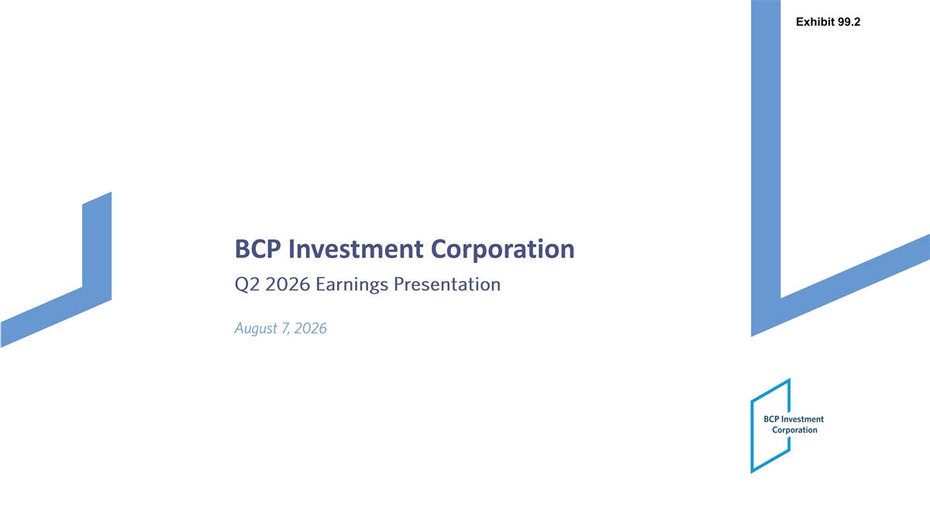
Exhibit 99.2 BCP Investment Corporation Q2 2026 Earnings Presentation August 7, 2026

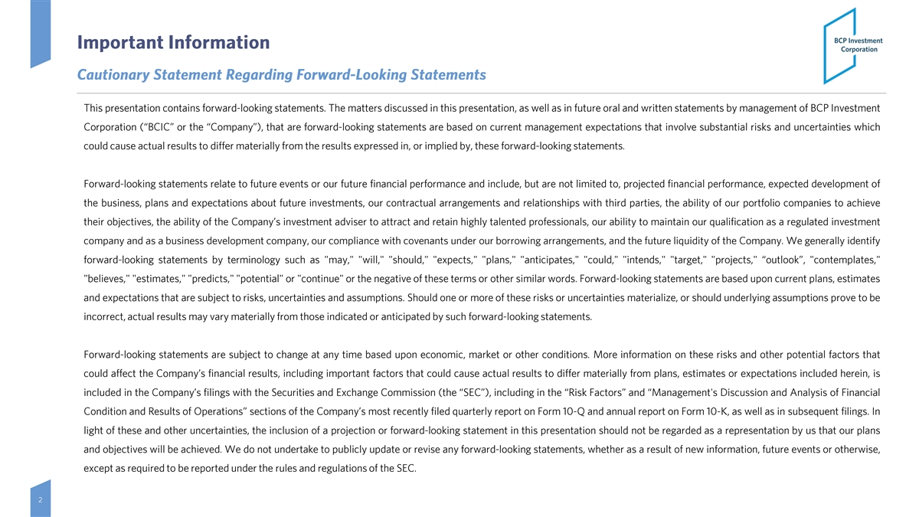
Important Information Cautionary Statement Regarding Forward -Looking Statements This presentation contains forward-looking statements. The matters discussed in this presentation, as well as in future oral and written statements by management of BCP Investment Corporation (“BCIC” or the “Company”), that are forward-looking statements are based on current management expectations that involve substantial risks and uncertainties which could cause actual results to differ materially from the results expressed in, or implied by, these forward-looking statements. Forward-looking statements relate to future events or our future financial performance and include, but are not limited to, projected financial performance, expected development of the business, plans and expectations about future investments, our contractual arrangements and relationships with third parties, the ability of our portfolio companies to achieve their objectives, the ability of the Company’s investment adviser to attract and retain highly talented professionals, our ability to maintain our qualification as a regulated investment company and as a business development company, our compliance with covenants under our borrowing arrangements, and the future liquidity of the Company . We generally identify forward-looking statements by terminology such as may, will, should, expects, plans, anticipates, could, intends, target, projects, “outlook”, contemplates, believes, estimates, predicts, potential or continue or the negative of these terms or other similar words. Forward-looking statements are based upon current plans, estimates and expectations that are subject to risks, uncertainties and assumptions . Should one or more of these risks or uncertainties materialize, or should underlying assumptions prove to be incorrect, actual results may vary materially from those indicated or anticipated by such forward-looking statements. Forward-looking statements are subject to change at any time based upon economic, market or other conditions. More information on these risks and other potential factors that could affect the Company’s financial results, including important factors that could cause actual results to differ materially from plans, estimates or expectations included herein, is included in the Company’s filings with the Securities and Exchange Commission (the “SEC”), including in the “Risk Factors” and “Management's Discussion and Analysis of Financial Condition and Results of Operations” sections of the Company’s most recently filed quarterly report on Form 10-Q and annual report on Form 10-K, as well as in subsequent filings. In light of these and other uncertainties, the inclusion of a projection or forward-looking statement in this presentation should not be regarded as a representation by us that our plans and objectives will be achieved. We do not undertake to publicly update or revise any forward-looking statements, whether as a result of new information, future events or otherwise, except as required to be reported under the rules and regulations of the SEC . 2

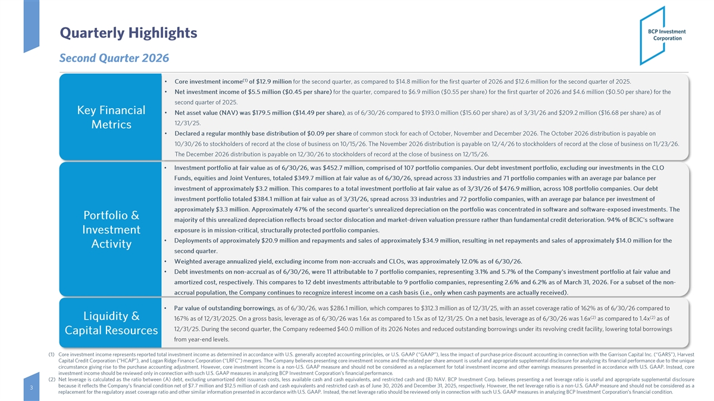
Quarterly Highlights Second Quarter 2026 (1) • Core investment income of $12.9 million for the second quarter, as compared to $14.8 million for the first quarter of 2026 and $12.6 million for the second quarter of 2025. • Net investment income of $5.5 million ($0.45 per share) for the quarter, compared to $6.9 million ($0.55 per share) for the first quarter of 2026 and $4.6 million ($0.50 per share) for the second quarter of 2025. Key Financial • Net asset value (NAV) was $179.5 million ($14.49 per share) , as of 6/30/26 compared to $193.0 million ($15.60 per share) as of 3/31/26 and $209.2 million ($16.68 per share) as of 12/31/25. Metrics • Declared a regular monthly base distribution of $0.09 per share of common stock for each of October, November and December 2026. The October 2026 distribution is payable on 10/30/26 to stockholders of record at the close of business on 10/15/26. The November 2026 distribution is payable on 12/4/26 to stockholders of record at the close of business on 11/23/26. The December 2026 distribution is payable on 12/30/26 to stockholders of record at the close of business on 12/15/26. • Investment portfolio at fair value as of 6/30/26, was $452.7 million, comprised of 107 portfolio companies. Our debt investme nt portfolio, excluding our investments in the CLO Funds, equities and Joint Ventures, totaled $349.7 million at fair value as of 6/30/26, spread across 33 industries and 71 po rtfolio companies with an average par balance per investment of approximately $3.2 million. This compares to a total investment portfolio at fair value as of 3/31/26 of $476.9 million, across 108 portfolio companies. Our debt investment portfolio totaled $384.1 million at fair value as of 3/31/26, spread across 33 industries and 72 portfolio compani es, with an average par balance per investment of approximately $3.3 million. Approximately 47% of the second quarter's unrealized depreciation on the portfolio was concentrat ed in software and software -exposed investments. The Portfolio & majority of this unrealized depreciation reflects broad sector dislocation and market -driven valuation pressure rather than fundamental cre dit deterioration. 94% of BCIC's software exposure is in mission -critical, structurally protected portfolio companies. Investment • Deployments of approximately $20.9 million and repayments and sales of approximately $34.9 million, resulting in net repaymen ts and sales of approximately $14.0 million for the Activity second quarter. • Weighted average annualized yield, excluding income from non -accruals and CLOs, was approximately 12.0% as of 6/30/26. • Debt investments on non -accrual as of 6/30/26, were 11 attributable to 7 portfolio companies, representing 3.1% and 5.7% of the Company's investment portfolio at fair value and amortized cost, respectively. This compares to 12 debt investments attributable to 9 portfolio companies, representing 2.6% a nd 6.2% as of March 31, 2026. For a subset of the non - accrual population, the Company continues to recognize interest income on a cash basis (i.e., only when cash payments are actually received ). • Par value of outstanding borrowings , as of 6/30/26, was $286.1 million, which compares to $312.3 million as of 12/31/25, with an asset coverage ratio of 162% as o f 6/30/26 compared to (2) (2) Liquidity & 167% as of 12/31/2025. On a gross basis, leverage as of 6/30/26 was 1.6x as compared to 1.5x as of 12/31/25. On a net basis, leverage as of 6/30/26 was 1.6x as compared to 1.4x as of 12/31/25. During the second quarter, the Company redeemed $40.0 million of its 2026 Notes and reduced outstanding borrowings under its revolving credit facility, lowering total borrowings Capital Resources from year-end levels. (1) Core investment income represents reported total investment income as determined in accordance with U.S. generally accepted accounting principles, or U.S. GAAP (“GAAP”), less the impact of purchase price discount accounting in connection with the Garrison Capital Inc. (“GARS”), Harvest Capital Credit Corporation (“HCAP”), and Logan Ridge Finance Corporation (“LRFC”) mergers. The Company believes presenting core investment income and the related per share amount is useful and appropriate supplemental disclosure for analyzing its financial performance due to the unique circumstance giving rise to the purchase accounting adjustment. However, core investment income is a non-U.S. GAAP measure and should not be considered as a replacement for total investment income and other earnings measures presented in accordance with U.S. GAAP . Instead, core investment income should be reviewed only in connection with such U.S. GAAP measures in analyzing BCP Investment Corporation’s financial performance. (2) Net leverage is calculated as the ratio between (A) debt, excluding unamortized debt issuance costs, less available cash and cash equivalents, and restricted cash and (B) NAV . BCP Investment Corp. believes presenting a net leverage ratio is useful and appropriate supplemental disclosure because it reflects the Company’s financial condition net of $7.7 million and $12.5 million of cash and cash equivalents and restricted cash as of June 30 , 2026 and December 31, 2025 , respectively. However, the net leverage ratio is a non-U.S. GAAP measure and should not be considered as a 3 replacement for the regulatory asset coverage ratio and other similar information presented in accordance with U.S. GAAP . Instead, the net leverage ratio should be reviewed only in connection with such U.S. GAAP measures in analyzing BCP Investment Corporation’s financial condition.

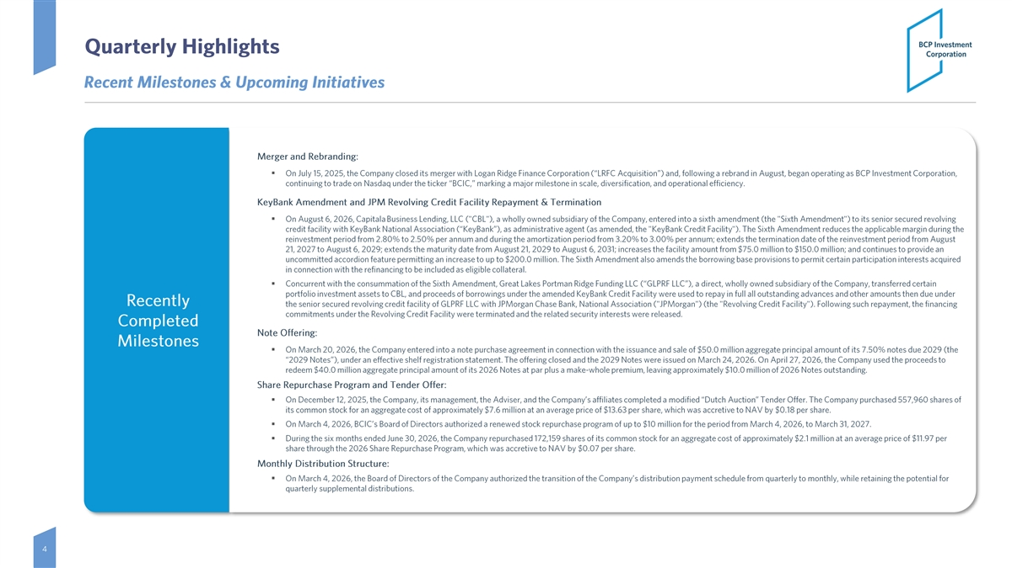
Quarterly Highlights Recent Milestones & Upcoming Initiatives Merger and Rebranding: ▪ On July 15, 2025, the Company closed its merger with Logan Ridge Finance Corporation (“LRFC Acquisition”) and, following a re brand in August, began operating as BCP Investment Corporation, continuing to trade on Nasdaq under the ticker “BCIC,” marking a major milestone in scale, diversification, and operational efficiency. KeyBank Amendment and JPM Revolving Credit Facility Repayment & Termination ▪ On August 6, 2026, Capitala Business Lending, LLC ( CBL ), a wholly owned subsidiary of the Company, entered into a sixth amendment (the Sixth Amendment ) to its senior secured revolving credit facility with KeyBank National Association (“KeyBank”), as administrative agent (as amended, the KeyBank Credit Facil ity ). The Sixth Amendment reduces the applicable margin during the reinvestment period from 2.80% to 2.50% per annum and during the amortization period from 3.20% to 3.00% per annum; extends t he termination date of the reinvestment period from August 21, 2027 to August 6, 2029; extends the maturity date from August 21, 2029 to August 6, 2031; increases the facility amount f rom $75.0 million to $150.0 million; and continues to provide an uncommitted accordion feature permitting an increase to up to $200.0 million. The Sixth Amendment also amends the borrowing b ase provisions to permit certain participation interests acquired in connection with the refinancing to be included as eligible collateral. ▪ Concurrent with the consummation of the Sixth Amendment, Great Lakes Portman Ridge Funding LLC (“GLPRF LLC”), a direct, wholl y owned subsidiary of the Company, transferred certain portfolio investment assets to CBL , and proceeds of borrowings under the amended KeyBank Credit Facility were used to repay in full all outstanding advances and other amounts then due under Recently the senior secured revolving credit facility of GLPRF LLC with JPMorgan Chase Bank, National Association ( JPMorgan ) (the R evolving Credit Facility ). Following such repayment, the financing commitments under the Revolving Credit Facility were terminated and the related security interests were released. Completed Note Offering: Milestones ▪ On March 20, 2026, the Company entered into a note purchase agreement in connection with the issuance and sale of $50.0 milli on aggregate principal amount of its 7.50% notes due 2029 (the “2029 Notes”), under an effective shelf registration statement. The offering closed and the 2029 Notes were issued on March 2 4, 2026. On April 27, 2026, the Company used the proceeds to redeem $40.0 million aggregate principal amount of its 2026 Notes at par plus a make -whole premium, leaving approximately $10.0 million of 2026 Notes outstanding. Share Repurchase Program and Tender Offer: ▪ On December 12, 2025, the Company, its management, the Adviser, and the Company’s affiliates completed a modified “Dutch Auct ion” Tender Offer. The Company purchased 557,960 shares of its common stock for an aggregate cost of approximately $7.6 million at an average price of $13.63 per share, which was accre tive to NAV by $0.18 per share. ▪ On March 4, 2026, BCIC’s Board of Directors authorized a renewed stock repurchase program of up to $10 million for the period from March 4, 2026, to March 31, 2027. ▪ During the six months ended June 30, 2026, the Company repurchased 172,159 shares of its common stock for an aggregate cost o f approximately $2.1 million at an average price of $11.97 per share through the 2026 Share Repurchase Program, which was accretive to NAV by $0.07 per share. Monthly Distribution Structure: ▪ On March 4, 2026, the Board of Directors of the Company authorized the transition of the Company’s distribution payment sched ule from quarterly to monthly, while retaining the potential for quarterly supplemental distributions. 4

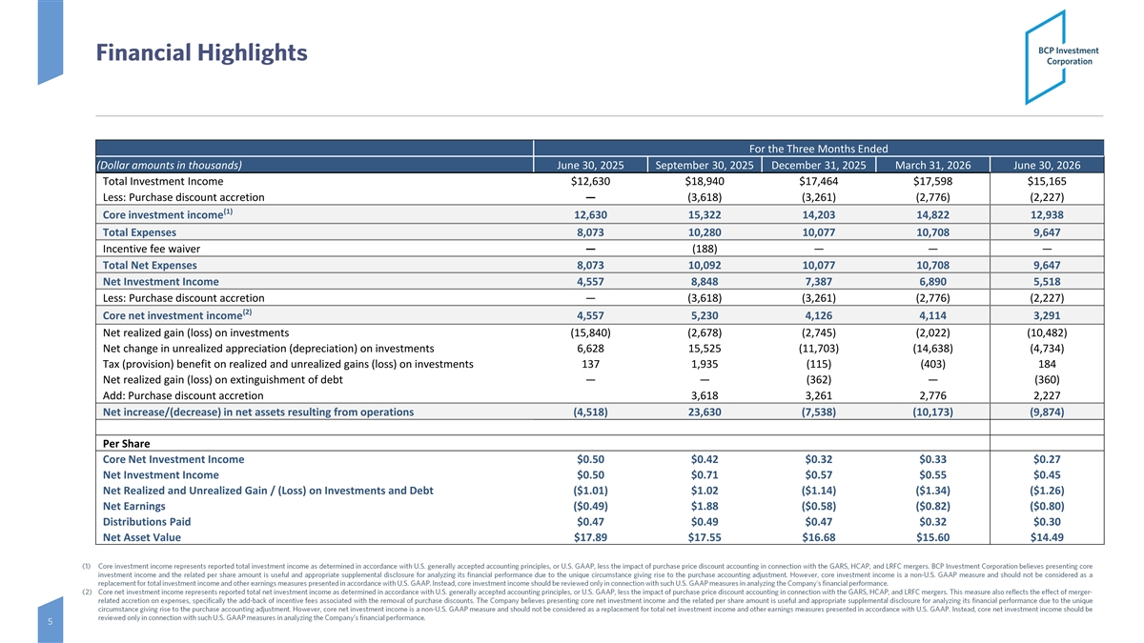
Financial Highlights For the Three Months Ended (Dollar amounts in thousands) June 30, 2025 September 30, 2025 December 31, 2025 March 31, 2026 June 30, 2026 Total Investment Income $12,630 $18,940 $17,464 $17,598 $15,165 Less: Purchase discount accretion— (3,618) (3,261) (2,776) (2,227) (1) Core investment income 12,630 15,322 14,203 14,822 12,938 Total Expenses 8,073 10,280 10,077 10,708 9,647 Incentive fee waiver— (188) — — — Total Net Expenses 8,073 10,092 10,077 10,708 9,647 Net Investment Income 4,557 8,848 7,387 6,890 5,518 Less: Purchase discount accretion — (3,618) (3,261) (2,776) (2,227) (2) Core net investment income 4,557 5,230 4,126 4,114 3,291 Net realized gain (loss) on investments (15,840) (2,678) (2,745) (2,022) (10,482) Net change in unrealized appreciation (depreciation) on investments 6,628 15,525 (11,703) (14,638) (4,734) Tax (provision) benefit on realized and unrealized gains (loss) on investments 137 1,935 (115) (403) 184 Net realized gain (loss) on extinguishment of debt — — (362) — (360) Add: Purchase discount accretion 3,618 3,261 2,776 2,227 Net increase/(decrease) in net assets resulting from operations (4,518) 23,630 (7,538) (10,173) (9,874) Per Share Core Net Investment Income $0.50 $0.42 $0.32 $0.33 $0.27 Net Investment Income $0.50 $0.71 $0.57 $0.55 $0.45 Net Realized and Unrealized Gain / (Loss) on Investments and Debt ($1.01) $1.02 ($1.14) ($1.34) ($1.26) Net Earnings ($0.49) $1.88 ($0.58) ($0.82) ($0.80) Distributions Paid $0.47 $0.49 $0.47 $0.32 $0.30 Net Asset Value $17.89 $17.55 $16.68 $15.60 $14.49 (1) Core investment income represents reported total investment income as determined in accordance with U.S. generally accepted accounting principles, or U.S. GAAP, less the impact of purchase price discount accounting in connection with the GARS, HCAP, and LRFC mergers. BCP Investment Corporation believes presenting core investment income and the related per share amount is useful and appropriate supplemental disclosure for analyzing its financial performance due to the unique circumstance giving rise to the purchase accounting adjustment. However, core investment income is a non-U.S. GAAP measure and should not be considered as a replacement for total investment income and other earnings measures presented in accordance with U.S. GAAP . Instead, core investment income should be reviewed only in connection with such U.S. GAAP measures in analyzing the Company's financial performance. (2) Core net investment income represents reported total net investment income as determined in accordance with U.S. generally accepted accounting principles, or U.S. GAAP, less the impact of purchase price discount accounting in connection with the GARS, HCAP, and LRFC mergers. This measure also reflects the effect of merger- related accretion on expenses, specifically the add-back of incentive fees associated with the removal of purchase discounts . The Company believes presenting core net investment income and the related per share amount is useful and appropriate supplemental disclosure for analyzing its financial performance due to the unique circumstance giving rise to the purchase accounting adjustment. However, core net investment income is a non-U.S. GAAP measure and should not be considered as a replacement for total net investment income and other earnings measures presented in accordance with U.S. GAAP . Instead, core net investment income should be reviewed only in connection with such U.S. GAAP measures in analyzing the Company’s financial performance. 5

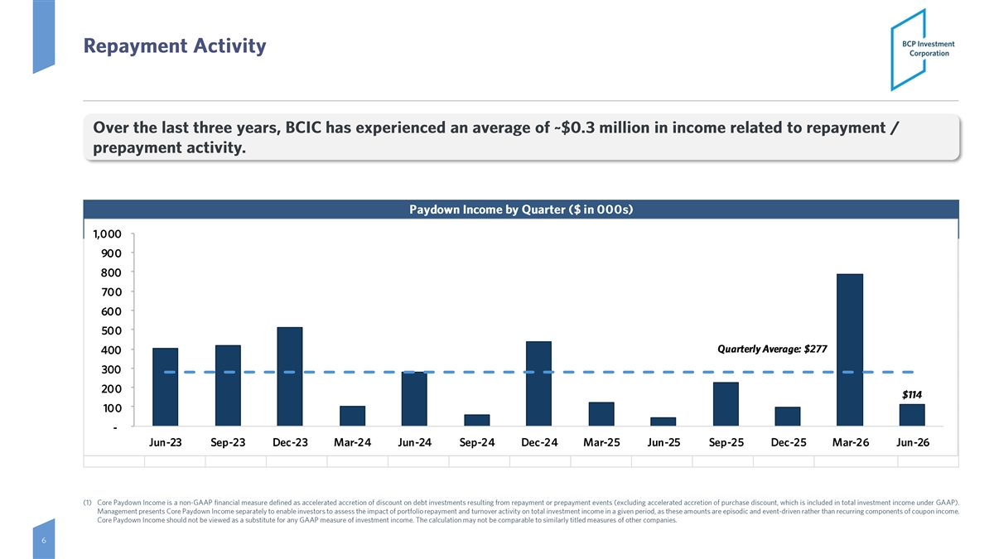
Repayment Activity Over the last three years, BCIC has experienced an average of ~$0.3 million in income related to repayment / prepayment activity. Paydown Income by Quarter ($ in 000s) 1,000 900 800 700 600 500 Quarterly Average: $277 400 300 200 $114 100 - Jun-23 Sep-23 Dec-23 Mar-24 Jun-24 Sep-24 Dec-24 Mar-25 Jun-25 Sep-25 Dec-25 Mar-26 Jun-26 (1) Core Paydown Income is a non-GAAP financial measure defined as accelerated accretion of discount on debt investments resulting from repayment or prepayment events (excluding accelerated accretion of purchase discount, which is included in total investment income under GAAP) . Management presents Core Paydown Income separately to enable investors to assess the impact of portfolio repayment and turnover activity on total investment income in a given period, as these amounts are episodic and event-driven rather than recurring components of coupon income. Core Paydown Income should not be viewed as a substitute for any GAAP measure of investment income. The calculation may not be comparable to similarly titled measures of other companies. 6

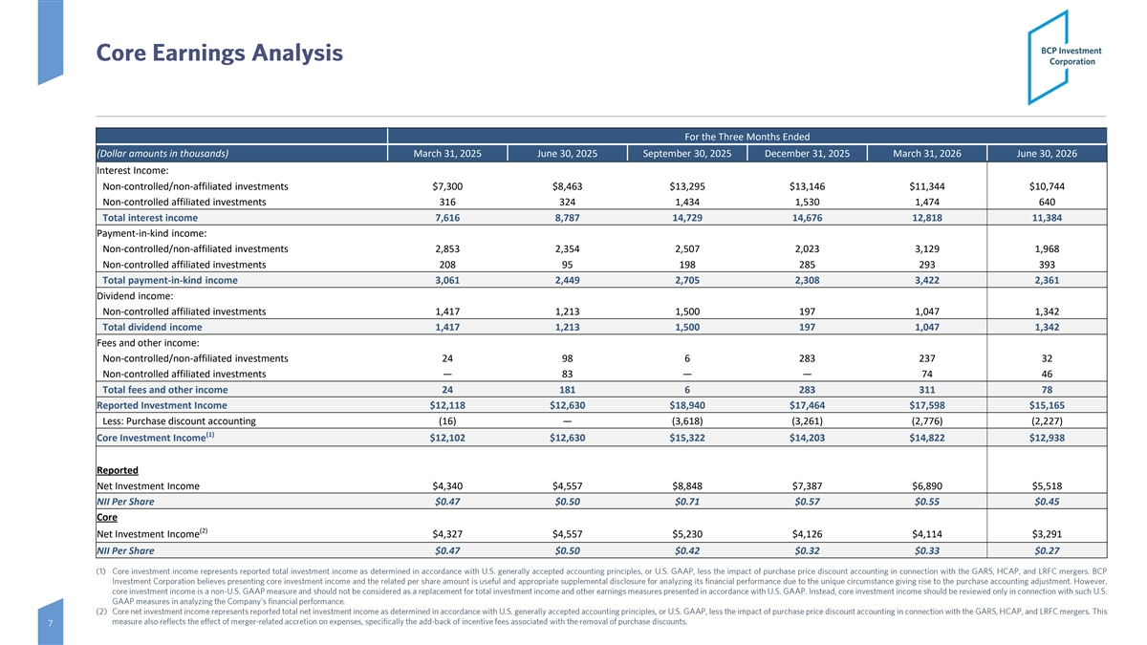
Core Earnings Analysis For the Three Months Ended (Dollar amounts in thousands) March 31, 2025 June 30, 2025 September 30, 2025 December 31, 2025 March 31, 2026 June 30, 2026 Interest Income: Non-controlled/non-affiliated investments $7,300 $8,463 $13,295 $13,146 $11,344 $10,744 Non-controlled affiliated investments 316 324 1,434 1,530 1,474 640 Total interest income 7,616 8,787 14,729 14,676 12,818 11,384 Payment-in-kind income: Non-controlled/non-affiliated investments 2,853 2,354 2,507 2,023 3,129 1,968 Non-controlled affiliated investments 208 95 198 285 293 393 Total payment-in-kind income 3,061 2,449 2,705 2,308 3,422 2,361 Dividend income: Non-controlled affiliated investments 1,417 1,213 1,500 197 1,047 1,342 Total dividend income 1,417 1,213 1,500 197 1,047 1,342 Fees and other income: Non-controlled/non-affiliated investments 24 98 6 283 237 32 Non-controlled affiliated investments — 83 — — 74 46 Total fees and other income 24 181 6 283 311 78 Reported Investment Income $12,118 $12,630 $18,940 $17,464 $17,598 $15,165 Less: Purchase discount accounting (16) — (3,618) (3,261) (2,776) (2,227) (1) Core Investment Income $12,102 $12,630 $15,322 $14,203 $14,822 $12,938 Reported Net Investment Income $4,340 $4,557 $8,848 $7,387 $6,890 $5,518 NII Per Share $0.47 $0.50 $0.71 $0.57 $0.55 $0.45 Core (2) Net Investment Income $4,327 $4,557 $5,230 $4,126 $4,114 $3,291 NII Per Share $0.47 $0.50 $0.42 $0.32 $0.33 $0.27 (1) Core investment income represents reported total investment income as determined in accordance with U.S. generally accepted accounting principles, or U.S. GAAP, less the impact of purchase price discount accounting in connection with the GARS, HCAP, and LRFC mergers. BCP Investment Corporation believes presenting core investment income and the related per share amount is useful and appropriate supplemental disclosure for analyzing its financial performance due to the unique circumstance giving rise to the purchase accounting adjustment. However, core investment income is a non-U.S. GAAP measure and should not be considered as a replacement for total investment income and other earnings measures presented in accordance with U.S. GAAP . Instead, core investment income should be reviewed only in connection with such U.S. GAAP measures in analyzing the Company’s financial performance. (2) Core net investment income represents reported total net investment income as determined in accordance with U.S. generally accepted accounting principles, or U.S. GAAP, less the impact of purchase price discount accounting in connection with the GARS, HCAP, and LRFC mergers. This measure also reflects the effect of merger-related accretion on expenses, specifically the add-back of incentive fees associated with the removal of purchase discounts. 7

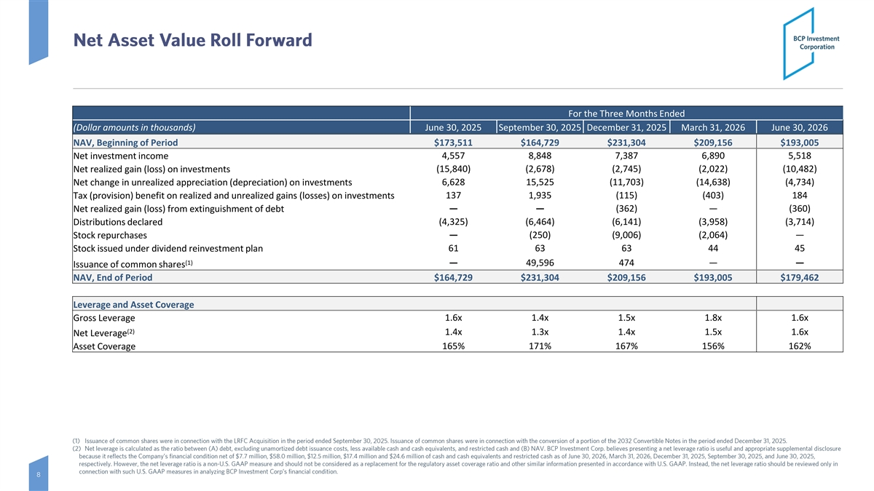
Net Asset Value Roll Forward For the Three Months Ended (Dollar amounts in thousands) June 30, 2025 September 30, 2025 December 31, 2025 March 31, 2026 June 30, 2026 NAV, Beginning of Period $173,511 $164,729 $231,304 $209,156 $193,005 Net investment income 4,557 8,848 7,387 6,890 5,518 (15,840) (2,678) (2,745) (2,022) (10,482) Net realized gain (loss) on investments Net change in unrealized appreciation (depreciation) on investments 6,628 15,525 (11,703) (14,638) (4,734) 137 1,935 (115) (403) 184 Tax (provision) benefit on realized and unrealized gains (losses) on investments Net realized gain (loss) from extinguishment of debt—— (362) — (360) (4,325) (6,464) (6,141) (3,958) (3,714) Distributions declared Stock repurchases— (250) (9,006) (2,064) — Stock issued under dividend reinvestment plan 61 63 63 44 45 (1) — 49,596 474 —— Issuance of common shares NAV, End of Period $164,729 $231,304 $209,156 $193,005 $179,462 Leverage and Asset Coverage Gross Leverage 1.6x 1.4x 1.5x 1.8x 1.6x (2) 1.4x 1.3x 1.4x 1.5x 1.6x Net Leverage Asset Coverage 165% 171% 167% 156% 162% (1) Issuance of common shares were in connection with the LRFC Acquisition in the period ended September 30, 2025. Issuance of co mmon shares were in connection with the conversion of a portion of the 2032 Convertible Notes in the period ended December 31, 2 025 . (2) Net leverage is calculated as the ratio between (A) debt, excluding unamortized debt issuance costs, less available cash and cash equivalents, and restricted cash and (B) NAV. BCP Investment Corp. believes presenting a net leverage ratio is useful and a ppropriate supplemental disclosure because it reflects the Company’s financial condition net of $7.7 million, $58.0 million, $12.5 million, $17.4 million and $2 4.6 million of cash and cash equivalents and restricted cash as of June 30, 2026, March 31, 2026, December 31, 2025, September 30 , 2025, and June 30, 2025, respectively. However, the net leverage ratio is a non -U.S. GAAP measure and should not be considered as a replacement for the r egulatory asset coverage ratio and other similar information presented in accordance with U.S. GAAP. Instead, the net leverag e ratio should be reviewed only in connection with such U.S. GAAP measures in analyzing BCP Investment Corp’s financial condition. 8

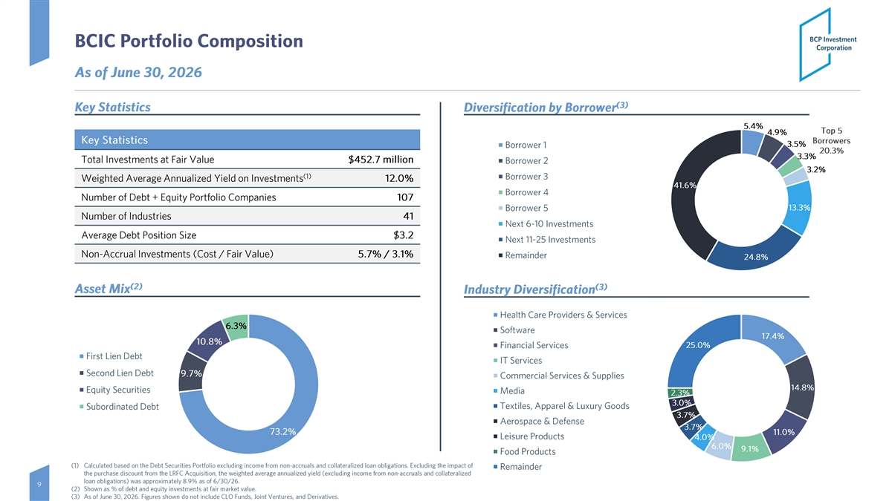
BCIC Portfolio Composition As of June 30, 2026 (3) Key Statistics Diversification by Borrower 5.4% Top 5 4.9% Key Statistics Borrowers 3.5% Borrower 1 20.3% 3.3% Total Investments at Fair Value $452.7 million Borrower 2 3.2% (1) Borrower 3 Weighted Average Annualized Yield on Investments 12.0% 41.6% Borrower 4 Number of Debt + Equity Portfolio Companies 107 13.3% Borrower 5 Number of Industries 41 Next 6-10 Investments Average Debt Position Size $3.2 Next 11-25 Investments Non-Accrual Investments (Cost / Fair Value) 5.7% / 3.1% Remainder 24.8% (2) (3) Asset Mix Industry Diversification Health Care Providers & Services 6.3% Software 17.4% 10.8% Financial Services 25.0% First Lien Debt IT Services Second Lien Debt 9.7% Commercial Services & Supplies 14.8% Equity Securities Media 2.3% 3.0% Textiles, Apparel & Luxury Goods Subordinated Debt 3.7% Aerospace & Defense 3.7% 73.2% 11.0% Leisure Products 4.0% 6.0% 9.1% Food Products (1) Calculated based on the Debt Securities Portfolio excluding income from non -accruals and collateralized loan obligations. Exclud ing the impact of Remainder the purchase discount from the LRFC Acquisition, the weighted average annualized yield (excluding income from non -accruals and c ollateralized loan obligations) was approximately 8.9% as of 6/30/26. 9 (2) Shown as % of debt and equity investments at fair market value. (3) As of June 30, 2026. Figures shown do not include CLO Funds, Joint Ventures, and Derivatives.

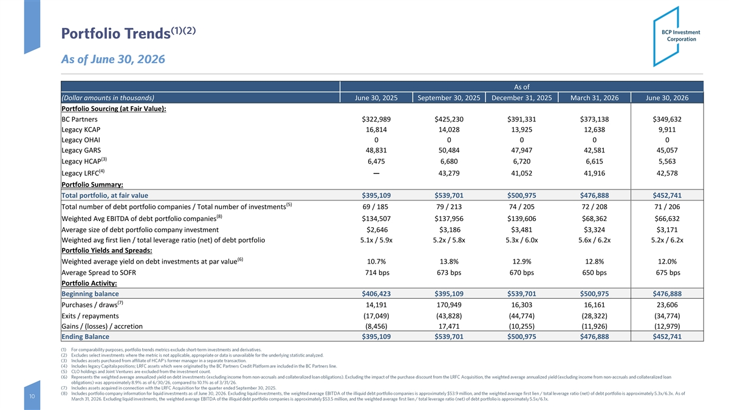
(1)(2) Portfolio Trends As of June 30, 2026 As of (Dollar amounts in thousands) June 30, 2025 September 30, 2025 December 31, 2025 March 31, 2026 June 30, 2026 Portfolio Sourcing (at Fair Value): BC Partners $322,989 $425,230 $391,331 $373,138 $349,632 Legacy KCAP 16,814 14,028 13,925 12,638 9,911 Legacy OHAI 0 0 0 0 0 Legacy GARS 48,831 50,484 47,947 42,581 45,057 (3) Legacy HCAP 6,475 6,680 6,720 6,615 5,563 (4) Legacy LRFC— 43,279 41,052 41,916 42,578 Portfolio Summary: Total portfolio, at fair value $395,109 $539,701 $500,975 $476,888 $452,741 (5) Total number of debt portfolio companies / Total number of investments 69 / 185 79 / 213 74 / 205 72 / 208 71 / 206 (8) Weighted Avg EBITDA of debt portfolio companies $134,507 $137,956 $139,606 $68,362 $66,632 Average size of debt portfolio company investment $2,646 $3,186 $3,481 $3,324 $3,171 Weighted avg first lien / total leverage ratio (net) of debt portfolio 5.1x / 5.9x 5.2x / 5.8x 5.3x / 6.0x 5.6x / 6.2x 5.2x / 6.2x Portfolio Yields and Spreads: (6) Weighted average yield on debt investments at par value 10.7% 13.8% 12.9% 12.8% 12.0% Average Spread to SOFR 714 bps 673 bps 670 bps 650 bps 675 bps Portfolio Activity: Beginning balance $406,423 $395,109 $539,701 $500,975 $476,888 (7) Purchases / draws 14,191 170,949 16,303 16,161 23,606 Exits / repayments (17,049) (43,828) (44,774) (28,322) (34,774) Gains / (losses) / accretion (8,456) 17,471 (10,255) (11,926) (12,979) Ending Balance $395,109 $539,701 $500,975 $476,888 $452,741 (1) For comparability purposes, portfolio trends metrics exclude short -term investments and derivatives. (2) Excludes select investments where the metric is not applicable, appropriate or data is unavailable for the underlying statist ic analyzed. (3) Includes assets purchased from affiliate of HCAP’s former manager in a separate transaction. (4) Includes legacy Capitala positions; LRFC assets which were originated by the BC Partners Credit Platform are included in the BC Partners line. (5) CLO holdings and Joint Ventures are excluded from the investment count. (6) Represents the weighted average annualized yield on debt investments (excluding income from non -accruals and collateralized loan obligations). Excluding the impact of the purchase discount from the LRFC Acquisition, the weighted average annualized yield (excluding income from non-accruals and collateralized loan obligations) was approximately 8.9% as of 6/30/26, compared to 10.1% as of 3/31/26. (7) Includes assets acquired in connection with the LRFC Acquisition for the quarter ended September 30, 2025. (8) Includes portfolio company information for liquid investments as of June 30, 2026. Excluding liquid investments, the weighted average EBITDA of the illiquid debt portfolio companies is approximately $53.9 million, and the weighted average first lien / t otal leverage ratio (net) of debt portfolio is approximately 5.3x/6.3x. As of 10 March 31, 2026. Excluding liquid investments, the weighted average EBITDA of the illiquid debt portfolio companies is approxi mately $53.5 million, and the weighted average first lien / total leverage ratio (net) of debt portfolio is approximately 5.5x/6 .1x.

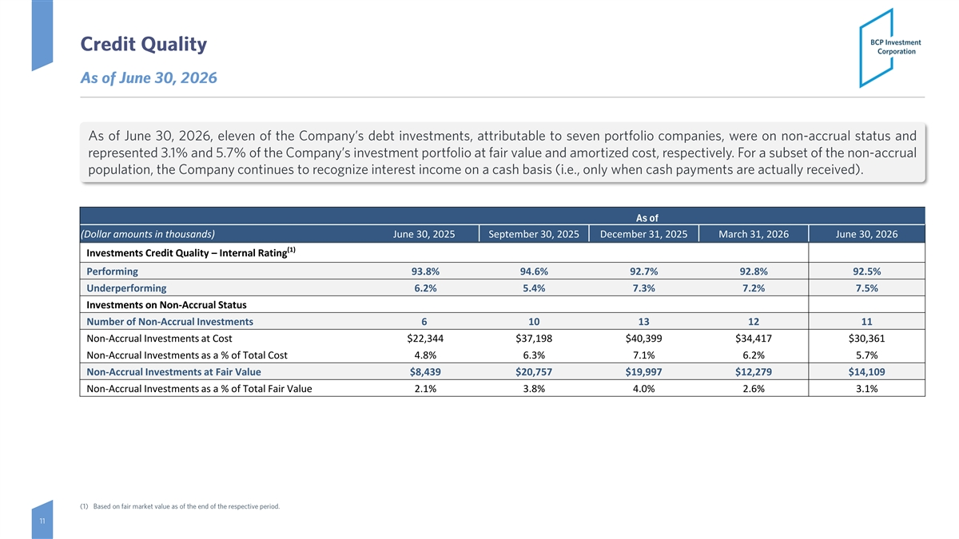
Credit Quality As of June 30, 2026 As of June 30, 2026 , eleven of the Company’s debt investments, attributable to seven portfolio companies, were on non-accrual status and represented 3.1% and 5.7% of the Company’s investment portfolio at fair value and amortized cost, respectively. For a subset of the non-accrual population, the Company continues to recognize interest income on a cash basis (i.e., only when cash payments are actually received). As of (Dollar amounts in thousands) June 30, 2025 September 30, 2025 December 31, 2025 March 31, 2026 June 30, 2026 (1) Investments Credit Quality – Internal Rating Performing 93.8% 94.6% 92.7% 92.8% 92.5% Underperforming 6.2% 5.4% 7.3% 7.2% 7.5% Investments on Non-Accrual Status Number of Non-Accrual Investments 6 10 13 12 11 Non-Accrual Investments at Cost $22,344 $37,198 $40,399 $34,417 $30,361 Non-Accrual Investments as a % of Total Cost 4.8% 6.3% 7.1% 6.2% 5.7% Non-Accrual Investments at Fair Value $8,439 $20,757 $19,997 $12,279 $14,109 Non-Accrual Investments as a % of Total Fair Value 2.1% 3.8% 4.0% 2.6% 3.1% (1) Based on fair market value as of the end of the respective period. 11

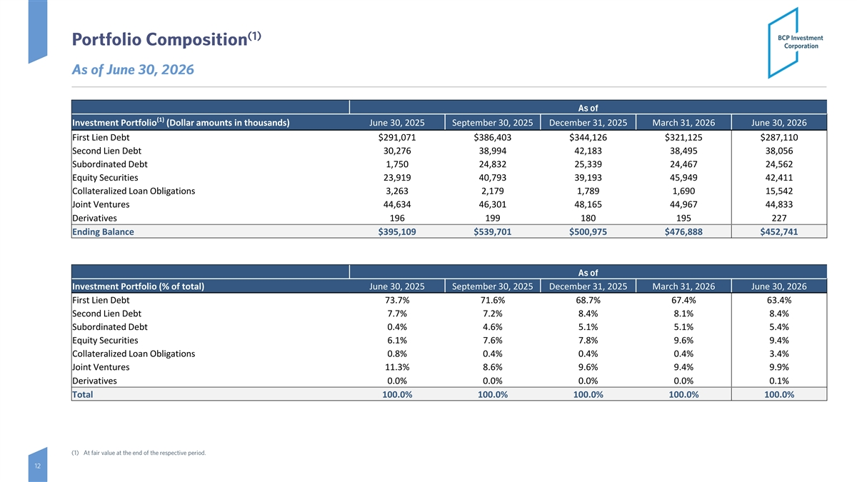
(1) Portfolio Composition As of June 30, 2026 As of (1) Investment Portfolio (Dollar amounts in thousands) June 30, 2025 September 30, 2025 December 31, 2025 March 31, 2026 June 30, 2026 First Lien Debt $291,071 $386,403 $344,126 $321,125 $287,110 Second Lien Debt 30,276 38,994 42,183 38,495 38,056 Subordinated Debt 1,750 24,832 25,339 24,467 24,562 Equity Securities 23,919 40,793 39,193 45,949 42,411 Collateralized Loan Obligations 3,263 2,179 1,789 1,690 15,542 Joint Ventures 44,634 46,301 48,165 44,967 44,833 Derivatives 196 199 180 195 227 Ending Balance $395,109 $539,701 $500,975 $476,888 $452,741 As of Investment Portfolio (% of total) June 30, 2025 September 30, 2025 December 31, 2025 March 31, 2026 June 30, 2026 First Lien Debt 73.7% 71.6% 68.7% 67.4% 63.4% Second Lien Debt 7.7% 7.2% 8.4% 8.1% 8.4% Subordinated Debt 0.4% 4.6% 5.1% 5.1% 5.4% Equity Securities 6.1% 7.6% 7.8% 9.6% 9.4% Collateralized Loan Obligations 0.8% 0.4% 0.4% 0.4% 3.4% Joint Ventures 11.3% 8.6% 9.6% 9.4% 9.9% Derivatives 0.0% 0.0% 0.0% 0.0% 0.1% Total 100.0% 100.0% 100.0% 100.0% 100.0% (1) At fair value at the end of the respective period. 12


Appendix Appendix

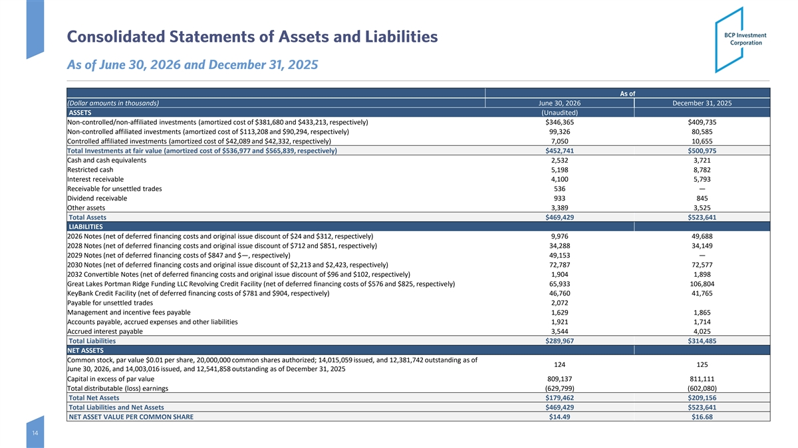
Consolidated Statements of Assets and Liabilities As of June 30, 2026 and December 31, 2025 As of (Dollar amounts in thousands) June 30, 2026 December 31, 2025 ASSETS (Unaudited) Non-controlled/non-affiliated investments (amortized cost of $381,680 and $433,213, respectively) $346,365 $409,735 Non-controlled affiliated investments (amortized cost of $113,208 and $90,294, respectively) 99,326 80,585 Controlled affiliated investments (amortized cost of $42,089 and $42,332, respectively) 7,050 10,655 Total Investments at fair value (amortized cost of $536,977 and $565,839, respectively) $452,741 $500,975 Cash and cash equivalents 2,532 3,721 Restricted cash 5,198 8,782 Interest receivable 4,100 5,793 Receivable for unsettled trades 536 — Dividend receivable 933 845 Other assets 3,389 3,525 Total Assets $469,429 $523,641 LIABILITIES 2026 Notes (net of deferred financing costs and original issue discount of $24 and $312, respectively) 9,976 49,688 2028 Notes (net of deferred financing costs and original issue discount of $712 and $851, respectively) 34,288 34,149 2029 Notes (net of deferred financing costs of $847 and $—, respectively) 49,153 — 2030 Notes (net of deferred financing costs and original issue discount of $2,213 and $2,423, respectively) 72,787 72,577 2032 Convertible Notes (net of deferred financing costs and original issue discount of $96 and $102, respectively) 1,904 1,898 Great Lakes Portman Ridge Funding LLC Revolving Credit Facility (net of deferred financing costs of $576 and $825, respectively) 65,933 106,804 KeyBank Credit Facility (net of deferred financing costs of $781 and $904, respectively) 46,760 41,765 Payable for unsettled trades 2,072 Management and incentive fees payable 1,629 1,865 Accounts payable, accrued expenses and other liabilities 1,921 1,714 Accrued interest payable 3,544 4,025 Total Liabilities $289,967 $314,485 NET ASSETS Common stock, par value $0.01 per share, 20,000,000 common shares authorized; 14,015,059 issued, and 12,381,742 outstanding as of 124 125 June 30, 2026, and 14,003,016 issued, and 12,541,858 outstanding as of December 31, 2025 Capital in excess of par value 809,137 811,111 Total distributable (loss) earnings (629,799) (602,080) $179,462 $209,156 Total Net Assets Total Liabilities and Net Assets $469,429 $523,641 NET ASSET VALUE PER COMMON SHARE $14.49 $16.68 14

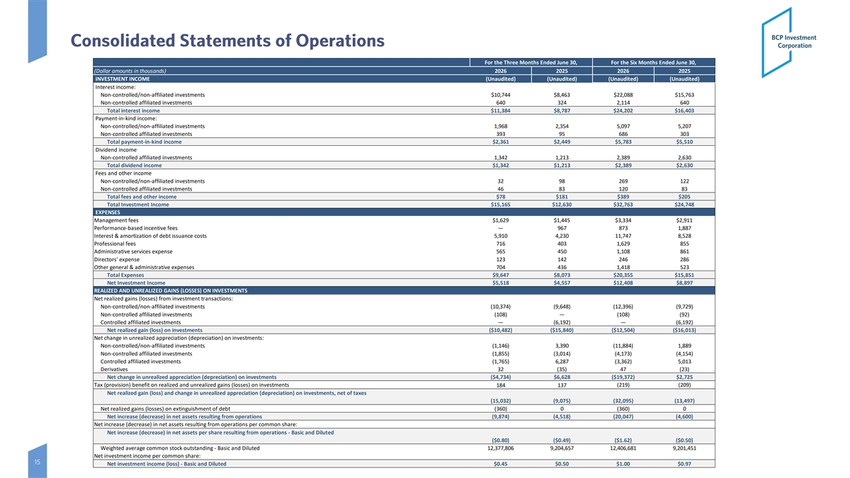
Consolidated Statements of Operations For the Three Months Ended June 30, For the Six Months Ended June 30, (Dollar amounts in thousands) 2026 2025 2026 2025 INVESTMENT INCOME (Unaudited) (Unaudited) (Unaudited) (Unaudited) Interest income: Non-controlled/non-affiliated investments $10,744 $8,463 $22,088 $15,763 Non-controlled affiliated investments 640 324 2,114 640 Total interest income $11,384 $8,787 $24,202 $16,403 Payment-in-kind income: Non-controlled/non-affiliated investments 1,968 2,354 5,097 5,207 Non-controlled affiliated investments 393 95 686 303 Total payment-in-kind income $2,361 $2,449 $5,783 $5,510 Dividend income Non-controlled affiliated investments 1,342 1,213 2,389 2,630 Total dividend income $1,342 $1,213 $2,389 $2,630 Fees and other income Non-controlled/non-affiliated investments 32 98 269 122 Non-controlled affiliated investments 46 83 120 83 Total fees and other income $78 $181 $389 $205 Total Investment Income $15,165 $12,630 $32,763 $24,748 EXPENSES Management fees $1,629 $1,445 $3,334 $2,911 Performance-based incentive fees — 967 873 1,887 Interest & amortization of debt issuance costs 5,910 4,230 11,747 8,528 Professional fees 716 403 1,629 855 Administrative services expense 565 450 1,108 861 Directors' expense 123 142 246 286 Other general & administrative expenses 704 436 1,418 523 Total Expenses $9,647 $8,073 $20,355 $15,851 Net Investment Income $5,518 $4,557 $12,408 $8,897 REALIZED AND UNREALIZED GAINS (LOSSES) ON INVESTMENTS Net realized gains (losses) from investment transactions: Non-controlled/non-affiliated investments (10,374) (9,648) (12,396) (9,729) Non-controlled affiliated investments (108) — (108) (92) Controlled affiliated investments — (6,192) — (6,192) Net realized gain (loss) on investments ($10,482) ($15,840) ($12,504) ($16,013) Net change in unrealized appreciation (depreciation) on investments: Non-controlled/non-affiliated investments (1,146) 3,390 (11,884) 1,889 Non-controlled affiliated investments (1,855) (3,014) (4,173) (4,154) Controlled affiliated investments (1,765) 6,287 (3,362) 5,013 Derivatives 32 (35) 47 (23) Net change in unrealized appreciation (depreciation) on investments ($4,734) $6,628 ($19,372) $2,725 Tax (provision) benefit on realized and unrealized gains (losses) on investments 184 137 (219) (209) Net realized gain (loss) and change in unrealized appreciation (depreciation) on investments, net of taxes (15,032) (9,075) (32,095) (13,497) Net realized gains (losses) on extinguishment of debt (360) 0 (360) 0 Net increase (decrease) in net assets resulting from operations (9,874) (4,518) (20,047) (4,600) Net increase (decrease) in net assets resulting from operations per common share: Net increase (decrease) in net assets per share resulting from operations - Basic and Diluted ($0.80) ($0.49) ($1.62) ($0.50) Weighted average common stock outstanding - Basic and Diluted 12,377,806 9,204,657 12,406,681 9,201,451 Net investment income per common share: 15 Net investment income (loss) - Basic and Diluted $0.45 $0.50 $1.00 $0.97

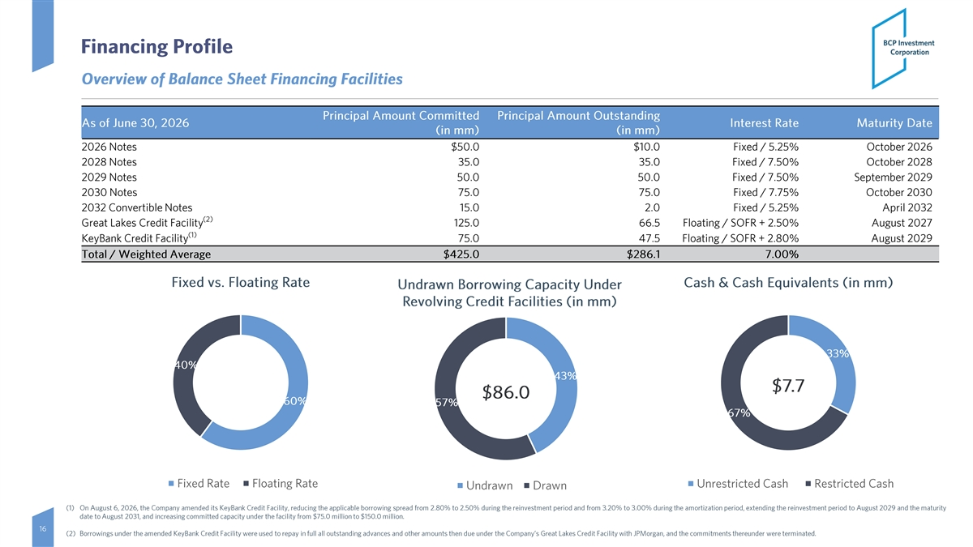
Financing Profile Overview of Balance Sheet Financing Facilities Principal Amount Committed Principal Amount Outstanding As of June 30, 2026 Interest Rate Maturity Date (in mm) (in mm) 2026 Notes $50.0 $10.0 Fixed / 5.25% October 2026 2028 Notes 35.0 35.0 Fixed / 7.50% October 2028 2029 Notes 50.0 50.0 Fixed / 7.50% September 2029 2030 Notes 75.0 75.0 Fixed / 7.75% October 2030 2032 Convertible Notes 15.0 2.0 Fixed / 5.25% April 2032 (2) Great Lakes Credit Facility 125.0 66.5 Floating / SOFR + 2.50% August 2027 (1) KeyBank Credit Facility 75.0 47.5 Floating / SOFR + 2.80% August 2029 Total / Weighted Average $425.0 $286.1 7.00% Fixed vs. Floating Rate Cash & Cash Equivalents (in mm) Undrawn Borrowing Capacity Under Revolving Credit Facilities (in mm) 33% 40% 43% $7.7 $86.0 60% 57% 67% Fixed Rate Floating Rate Unrestricted Cash Restricted Cash Undrawn Drawn (1) On August 6, 2026 , the Company amended its KeyBank Credit Facility, reducing the applicable borrowing spread from 2.80 % to 2.50 % during the reinvestment period and from 3.20 % to 3.00 % during the amortization period, extending the reinvestment period to August 2029 and the maturity date to August 2031, and increasing committed capacity under the facility from $75.0 million to $150.0 million. 16 (2) Borrowings under the amended KeyBank Credit Facility were used to repay in full all outstanding advances and other amounts then due under the Company’s Great Lakes Credit Facility with JPMorgan, and the commitments thereunder were terminated.

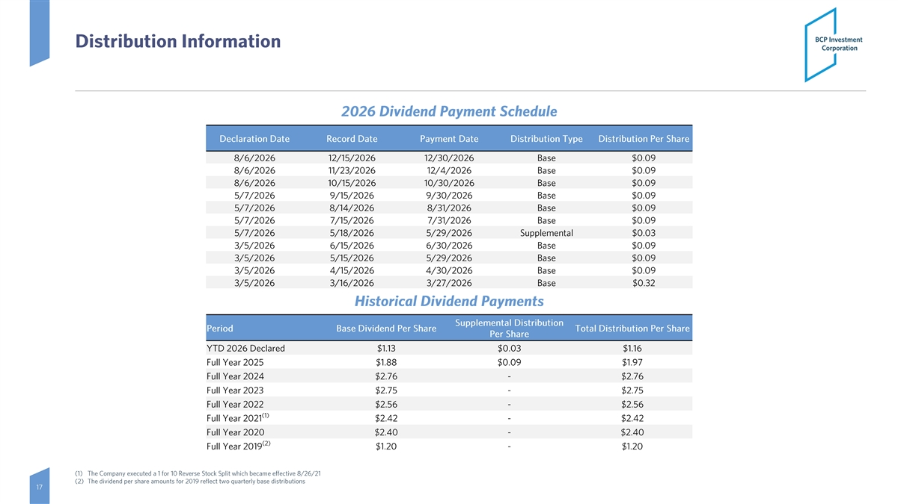
Distribution Information 2026 Dividend Payment Schedule Declaration Date Record Date Payment Date Distribution Type Distribution Per Share 8/6/2026 12/15/2026 12/30/2026 Base $0.09 8/6/2026 11/23/2026 12/4/2026 Base $0.09 8/6/2026 10/15/2026 10/30/2026 Base $0.09 5/7/2026 9/15/2026 9/30/2026 Base $0.09 5/7/2026 8/14/2026 8/31/2026 Base $0.09 5/7/2026 7/15/2026 7/31/2026 Base $0.09 5/7/2026 5/18/2026 5/29/2026 Supplemental $0.03 3/5/2026 6/15/2026 6/30/2026 Base $0.09 3/5/2026 5/15/2026 5/29/2026 Base $0.09 3/5/2026 4/15/2026 4/30/2026 Base $0.09 3/5/2026 3/16/2026 3/27/2026 Base $0.32 Historical Dividend Payments Supplemental Distribution Period Base Dividend Per Share Total Distribution Per Share Per Share YTD 2026 Declared $1.13 $0.03 $1.16 Full Year 2025 $1.88 $0.09 $1.97 Full Year 2024 $2.76 - $2.76 Full Year 2023 $2.75 - $2.75 Full Year 2022 $2.56 - $2.56 (1) Full Year 2021 $2.42 - $2.42 Full Year 2020 $2.40 - $2.40 (2) Full Year 2019 $1.20 - $1.20 (1) The Company executed a 1 for 10 Reverse Stock Split which became effective 8/26/21 (2) The dividend per share amounts for 2019 reflect two quarterly base distributions 17

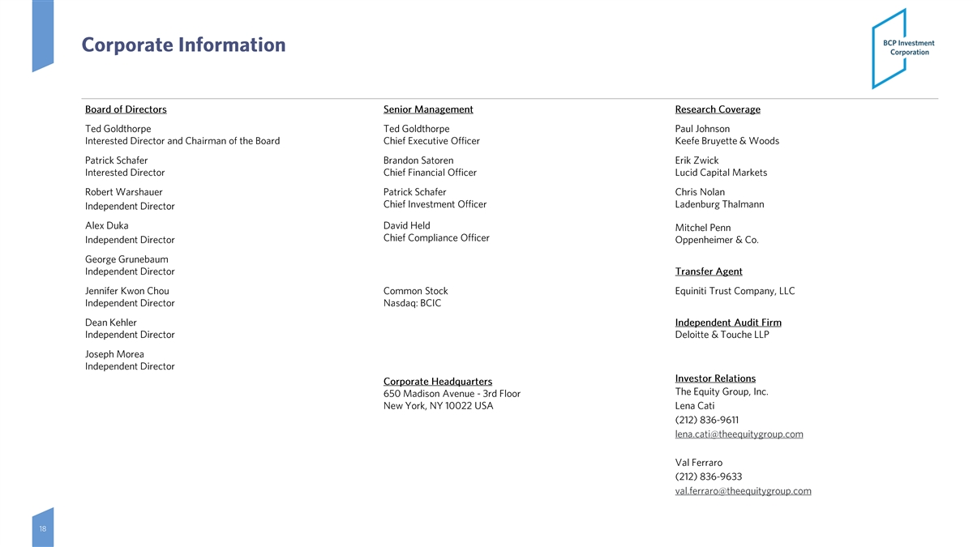
Corporate Information Board of Directors Senior Management Research Coverage Ted Goldthorpe Ted Goldthorpe Paul Johnson Interested Director and Chairman of the Board Chief Executive Officer Keefe Bruyette & Woods Patrick Schafer Brandon Satoren Erik Zwick Interested Director Chief Financial Officer Lucid Capital Markets Robert Warshauer Patrick Schafer Chris Nolan Chief Investment Officer Ladenburg Thalmann Independent Director Alex Duka David Held Mitchel Penn Chief Compliance Officer Independent Director Oppenheimer & Co. George Grunebaum Independent Director Transfer Agent Jennifer Kwon Chou Common Stock Equiniti Trust Company, LLC Independent Director Nasdaq: BCIC Dean Kehler Independent Audit Firm Independent Director Deloitte & Touche LLP Joseph Morea Independent Director Investor Relations Corporate Headquarters The Equity Group, Inc. 650 Madison Avenue - 3rd Floor New York, NY 10022 USA Lena Cati (212) 836 -9611 lena.cati@theequitygroup.com Val Ferraro (212) 836 -9633 val.ferraro@theequitygroup.com 18

